**SQL aggregate functions :**

SQL aggregate functions perform calculations on a set of values and return a single value as the result. These functions are commonly used with the SELECT statement to compute summaries of data, such as totals, averages, counts, and maximum/minimum values. Let's explore some common SQL aggregate functions with examples:

**1. COUNT():**

The COUNT() function counts the number of rows in a result set.



This query will return the total number of employees in the Employees table.

**2. SUM():**

The SUM() function calculates the sum of values in a numeric column.



This query will return the total salary of all employees.

**3. AVG():**

The AVG() function calculates the average value of a numeric column. 

This query will return the average salary of all employees.

**4. MAX():**

The MAX() function returns the maximum value in a column.

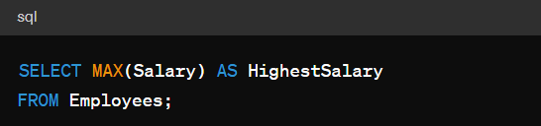

This query will return the highest salary among all employees.

**5. MIN():**

The MIN() function returns the minimum value in a column.



This query will return the lowest salary among all employees.

**6. GROUP BY with Aggregate Functions:**

You can use aggregate functions with the GROUP BY clause to calculate summaries for groups of rows.

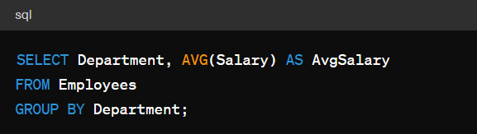

This query will return the average salary for each department.

**7. HAVING:**

The HAVING clause filters groups of rows based on specified conditions.



**Example:**

This query will return departments with an average salary greater than $50,000.

Aggregate functions are powerful tools for analyzing and summarizing data in SQL, allowing you to derive valuable insights from your database.